Knowledge Repository & Interactive Skill-building Portal

AN INTERNSHIP REPORT



# Sivamani Yadav Yeti [RA2111030010073]





Dr.A.PRAVEENA

Associate Professor, Department of Networking and Communications





BACHELOR OF TECHNOLOGY

in

COMPUTER SCIENCE ENGINEERING

with specialization in CYBER SECURITY



DEPARTMENT OF NETWORKING AND COMMUNICATIONS

SCHOOL OF COMPUTING

COLLEGE OF ENGINEERING AND TECHNOLOGY SRM INSTITUTE OF SCIENCE ANDTECHNOLOGY

KATTANKULATHUR- 603203

## MAY 2025

### Department of Networking and Communications

SRM Institute of Science & Technology Own Work Declaration Form

This sheet must be filled in (each box ticked to show that the condition has been met). It must be signed and dated along with your student registration number and included with all assignments you submit – work will not be marked unless this is done.

To be completed by the student for all

### assessments Degree/ Course : B.TECH / CSE Student Name : Sivamani Yadav Yeti Registration Number : RA2111030010073

Title of Work : KRISP

I hereby certify that this assessment compiles with the University’ s Rules and Regulations relating to Academic misconduct and plagiarism, as listed in the University Website, Regulations, and the Education Committee guidelines.

I confirm that all the work contained in this assessment is our own except where indicated, and that we have met the following conditions:

Clearly referenced / listed all sources as appropriate

Referenced and put in inverted commas all quoted text (from books, web, etc) Given the sources of all pictures, data etc. that are not my own

Not made any use of the report(s) or essay(s) of any other student(s) either past or present Acknowledged in appropriate places any help that I have received from others (e.g.fellow students, technicians, statisticians, external sources)

Compiled with any other plagiarism criteria specified in the Course handbook /University website

We understand that any false claim for this work will be penalized in accordance with the University policies and regulations.

|  |
| --- |
| DECLARATION: |
| We are aware of and understand the University’ s policy on Academic misconduct and plagiarism and we certify that this assessment is our own work, except where indicated by referring, and that we have followed the good academic practices noted above. |
| RA2111030010073 Sivamani Yadav Yeti |

# ACKNOWLEDGEMENT

We express our humble gratitude to Dr. C. Muthamizhchelvan, Vice-Chancellor, SRM Institute of Science and Technology, for the facilities extended for the project work and his continued support.

We extend our sincere thanks to Dean-CET, SRM Institute of Science and Technology, Dr.T.V. Gopal, for his invaluable support.

We wish to thank Dr. Revathi Venkataraman, Professor & Chairperson, School of Computing, SRM Institute of Science and Technology, for her support throughout the project work.

We are incredibly grateful to our Head of the Department, Dr. Annapurani K, Professor and Head, Department of Networking and Communications, School of Computing, SRM Institute of Science and Technology, for her suggestions and encouragement at all the stages of the project work.

We want to convey our thanks to our Project Coordinator, Dr. G. Suseela, Associate Professor, Panel Head, Dr.A.Praveena , Associate Professor and panel Dr. Meenakshi K, Assistant Professor, Dr.Logeshwari, Assistant Professor, Department of Networking and Communications, School of Computing, SRM Institute of Science and Technology, for their inputs during the project reviews and support.

We register our immeasurable thanks to our Faculty Advisor, Dr. Balaji Srikaanth P, Department of Networking and Communications, School of Computing, SRM Institute of Science and Technology, for leading and helping us to complete our course.

Our inexpressible respect and thanks to our guide, Dr. G. Suseela, Associate Professor, Department of Networking and Communications, SRM Institute of Science and Technology, for providing us with an opportunity to pursue our project under her mentorship. She provided us with the freedom and support to explore the research topics of our interest. Her passion for solving problems and making a difference in the world has

always been inspiring.

We sincerely thank the Networking and Communications Department staff and students, SRM Institute of Science and Technology, for their help during our project. Finally, we would like to thank parents, family members, and friends for their unconditional love, constant support, and encouragement.

Sivamani Yadav Yeti [RA2111030010073]



# SRM INSTITUTE OF SCIENCE AND TECHNOLOGY KATTANKULATHUR – 603 203

BONAFIDE CERTIFICATE

Certified that 18CSP111L project report titled “ KRISP” is the bonafide work of “ Sivamani Yadav Yeti [RA2111030010073]” who carried out the project work under my supervision. Certified further, that to the best of my knowledge the work reported herein does not form any other project report or dissertation on the basis

of which a degree or award was conferred on an earlier occasion on this or any other candidate.

### SIGNATURE SIGNATURE

Dr. A. Praveena Dr. ANNAPURANI K.

### SUPERVISOR

Associate Professor Department of Networking and Communications

Internal Examiner

### HEAD OF THE DEPARTMENT

Professor

Department of Networking and Communications

External Examiner

Incedo Technology Solutions Limited CIN:

U72200DL2011PLC220071

Corporate Office : 248,Udyog Vihar, Phase-IV, Gurugram-122015

Registered Office: A-47, Lower Ground Floor, Hauz Khas, New Delhi-110016 [inquiries@incedoinc.com](mailto:inquiries@incedoinc.com) | [www.incedoinc.com](http://www.incedoinc.com/)

December 16, 2024 Vunadi Reddy

F2,tower-4 tatha buildings,backside of minimatrix appatment,alle nagar,potheri chengalpattu, 603203

LETTER FOR INTERNSHIP

Dear Vunadi Reddy,

Congratulations! With reference toyour application and subsequent interview(s) youhad with us, we arepleased toofferyou internship with Incedo starting January 8, 2025 as per the below terms and conditions

Designation: Intern

Chennai

Department: Delivery Function

Duration: 8th Jan 2025 - 8th July 2025

Stipend: INR 15,000 per month

Please note this is the internship confirmation letter, internship completion letter will be issued only after successful completion of the training.

This internship is convertible into an employment with the company subject to the terms mentioned in your appointment



letter and submission of below self-attested documents.

 Educational documents: 10th, 12th, Graduation Degree, Post-Graduation Degree (if applicable)  Address proof: Passport/Driving license/ Voter ID card/Aadhaar card

 PAN card copy (Mandatory)

 Aadhaar card copy (Mandatory)

 Work experience letter of previous organizations (if applicable)

 One (1) coloured photograph (passport size, with white background)  Resume





We understand that your final semester results are still awaited. Please note, that management reserves the right to terminate your employment with or without notice in case your final results are not as per our expectations.



The Company may, at its sole and absolute discretion, conduct background checks prior toor after joining or at any time in



future, to check but not limited to your identity, the address provided by you, your education background and past work experience, past antecedents, drug tests and/or any other test or verification. You expressly consent to the Company conducting above checks. You are required to furnish the documents listed in the "Appointment Letter", "Background Verification Form" or any other document as may be required. If the Company, is not satisfied, in its sole and absolute subjective discretion, with the outcome of the aforesaid checks, the Company may (I) Reserve the right to withdraw the Offer made to you without any notice and Compensation (II) Or may treat your appointment as null and void ab-initio (III) Or it may take such other appropriate action as may be advised.

Attending and completing all trainings scheduled for your post your joining, and qualifying the assessment is a critical



requirement for the employment. If the Company, is not satisfied, in its sole and absolute discretion, with the outcome of the aforesaid assessment, the Company (i) Reserves the right to withdraw the Offer made to you without any notice and compensation ; OR (ii) may treat your appointment as null and void ab-initio; OR (iii) may take such other appropriate action as may be advised.

In case, you decide to leave Incedo during your internship period under any circumstances, we recommend providing an



advance notice of 4 weeks for a smooth transition.

You shall always comply with the Company’s policies/guidelines. Management reserves the rights toamend or modify the existing policies/guidelines as required, at its sole discretion, any time during the year, with or without notice.



Wishing you a good learning experience at Incedo!

FOR INCEDO TECHNOLOGYSOLUTIONSLIMITED



(ESHA GULATI) AUTHORIZED SIGNATORY HUMAN RESOURCES



# ABSTRACT

KRISP outlines the detailed technical design of the system, covering module-level functionalities, data flow, and system architecture. It provides a structured approach to implementing features like role-based dashboards, training progress tracking, and analytics generation**.** This document serves as a reference for developers, architects, and testers to ensure a scalable, secure, and efficient system.

Insight360 is an intelligent, dynamic dashboard platform designed to enhance organizational efficiency, transparency, and collaboration through robust role-based access control (RBAC). It caters to four primary roles within an enterprise—Admin, Manager, Module Buddy, and Employee—each with clearly defined permissions and tailored access to features and data relevant to their responsibilities. The platform delivers a personalized experience for each user by dynamically rendering dashboards, insights, and actionable tools specific to their role, ensuring both usability and security.

The Admin has complete control over system configurations, user management, and access policies. Managers can track team performance, assign tasks, and analyze key metrics in real time. Module Buddies are empowered to provide support and guidance within specific functional modules, acting as bridges between employees and management. Employees can view their tasks, submit reports, interact with their teams, and receive updates—all within a simplified interface. Built using modern web technologies, Insight360 supports seamless integration with backend services and databases, ensuring data consistency and real-time synchronization. The architecture emphasizes modularity, scalability, and security, making it adaptable to growing organizational needs. With advanced analytics, intuitive UI/UX, and a centralized control system, Insight360 empowers stakeholders at every level to make informed decisions, improve productivity, and foster a culture of accountability and transparency within the organi

# TABLE OF CONTENTS

INTERNSHIP OFFER LETTER i **i**

ACKNOWLEDGEMENT v

ABSTRACT vi

LIST OF FIGURES xii

LIST OF TABLES x **i**i

LIST OF ACRONYMS AND ABBREVIATIONS xiv

CHAPTER NO. TITLE PAGE NO.

1. INTRODUCTION 1
   1. Overview 1
   2. Objectives Of The System 1
   3. Scope Of The Project 2
   4. Technologies Used 2
      1. Backend Technologies 2
      2. Frontend Technologies 3
      3. Database and Infrastructure 3
2. LITERATURE SURVEY 4
   1. Existing Food Delivery Systems 4
   2. Challenges in Online Food Delivery 5
   3. Proposed System 5
3. SYSTEM REQUIREMENTS 6
   1. Functional Requirements 6
   2. Software Requirements 6
   3. Hardware Requirements 6
4. SYSTEM ARCHITECTURE AND DESIGN 7
   1. System Overview 7
   2. Class Diagram 7
   3. Sequence Diagram 8
   4. Data Flow Diagram 9
5. METHODOLOGY AND IMPLEMENTATION 11
   1. User Roles and Functionalities 11

|  |  |  |  |  |
| --- | --- | --- | --- | --- |
| 5.1.1 | | | Admin | 11 |
| 5.1.2 | | | User | 11 |
| 5.1.3 | | | Restaurant | 11 |
| 5.1.4 | | | Delivery Agent | 11 |
| 5.2 | | Database Design and Implementation | | 12 |
|  | | 5.2.1 Admin Schema | | 12 |
|  | | 5.2.2 User Schema | | 13 |
|  | | 5.2.3 Restaurant Schema | | 13 |
|  | | 5.2.4 Delivery Agent Schema | | 14 |
|  | 5.3 Admin Dashboard and User Managment | | | 14 |
|  | 5.4 Customer Portal | | | 25 |
|  | 5.5 Restaurant Management Portal | | | 37 |
|  | 5.6 Delivery Agent Portal | | | 44 |
| 6 | CONCLUSION AND FUTURE ENHANCEMENTS | | | 52 |
|  | 6.1 Conclusion | | | 52 |
|  | 6.2 Future Scope | | | 52 |
|  | REFERENCES | | | 53 |
|  | BIBILIOGRAPHY | | | 54 |
| APPENDIX  A | PLAGIARISM REPORT | | | 55 |

## LIST OF FIGURES

|  |  |  |  |
| --- | --- | --- | --- |
| FIG | NO. | FIGURE NAME | PAGE NO. |
| 4.1 |  | Class Diagram Of Korporate Kitchen | 7 |
| 4.2 |  | Sequence Diagram Of Korporate Kitchen | 8 |
| 4.3 |  | Data Flow Diagram Of Korporate Kitchen | 9 |
| 5.1 |  | Admin Schema | 12 |
| 5.2 |  | User Schema | 13 |
| 5.3 |  | Restaurant Schema | 13 |
| 5.4 |  | Delivery Agent Schema | 14 |
| 5.5 |  | Admin Portal | 20 |
| 5.6 |  | Admin Dashboard | 21 |
| 5.7 |  | Admin Profile | 22 |
| 5.8 |  | User Management | 23 |
| 5.9 |  | Restaurant Management | 24 |
| 5.10 |  | Delivery Agents Management | 25 |
| 5.11 |  | Customer Home Page | 30 |
| 5.12 |  | Login/Registration Page | 31 |
| 5.13 |  | User Dashboard | 34 |
| 5.14 |  | User Cart | 35 |
| 5.15 |  | User Remarks | 36 |
| 5.16 |  | Restaurant Portal | 42 |
| 5.17 |  | Restaurant Dashboard | 44 |
| 5.18 |  | Delivery Partner Portal | 49 |
| 5.19 |  | Delivery Partner Registration | 50 |
| 5.20 |  | Delivery Partner Dashboard | 51 |

LIST OF TABLES

WEEKLY OVERVIEW OF INTERNSHIPACTIVITIES

WEEK NO. PAGE NO.

WEEK-1 xv

WEEK-2 xv

WEEK-3 xvi

WEEK-4 xvi

## LIST OF ACRONYMS AND ABBREVIATIONS

JSP Java Server Pages

JSTL Java Server Pages Standard Tag Library

JDK Java Development Kit

IDE Integrated Development Environment

MVC Model-View-Controller

REST Representational State Transfer

UI/UX User Interface/User Experience

API Application Programming Interface

CRUD Create, Read, Update, Delete

JPA Java Persistence API

CSS Cascading Style Sheets

SQL Structured Query Language

VRPTW Vehicle Routing Problem with Time Windows

UML Unified Markup Language

ORM Object-Relational Mapping

GPS Global Positioning System

UPI Unified Payments Interface

Learning Objectives/Internship Objectives

Internships are generally thought of to be reserved for college students looking to gain experience in a particular field. However, a wide array of people can benefit from Training Internships in order to receive real world experience and develop their skills.

An objective for this position should emphasize the skills you already possess in the area and your interest in learning more

Internships are utilized in a number of different career fields, including architecture, engineering, healthcare, economics, advertising and many more.

Some internship is used to allow individuals to perform scientific research while others are specifically designed to allow people to gain first-hand experience working.

Utilizing internships is a great way to build your resume and develop skills that can be emphasized in your resume for future jobs. When you are applying for a Training Internship, make sure to highlight any special skills or talents that can make you stand apart from the rest of the applicants so that you have an improved chance of landing the position.

# CHAPTER 1

INTRODUCTION

### **Overview**

KRISP-**Insight** is an intelligent, dynamic dashboard platform designed to enhance organizational efficiency, transparency, and collaboration through robust Role-Based Access Control (RBAC). It serves four primary user roles—**Admin**, **Manager**, **Module Buddy**, and **Employee**—providing each with a personalized and secure interface that caters specifically to their responsibilities. By leveraging real-time analytics, modular architecture, and seamless integration capabilities, Insight360 empowers enterprises to make data-driven decisions, optimize workflows, and foster accountability at every level.

### **Objectives Of The System**

### The main objectives of Insight360 are to:

### Provide a personalized and secure dashboard experience for each user based on their role.

### Enhance organizational transparency and collaboration by clearly defining role-specific responsibilities and access.

### Allow real-time performance tracking, feedback management, and training oversight across departments.

### Enable centralized control and monitoring of users, tasks, and system usage.

### Improve decision-making through robust reporting and analytics tools.

### Ensure scalability, modularity, and security to support the growing needs of modern enterprises.

### **Scope Of The Project:**

### The project encompasses the development and deployment of a full-stack web application that includes:

### Secure authentication through Okta or Azure Active Directory.

### Dynamic, role-based dashboards for Admins, Managers, Module Buddies, and Employees.

### Functional modules for user and role management, training content management, feedback processing, and performance analytics.

### Responsive UI/UX with Material UI for a consistent user experience across devices.

### Integration with a PostgreSQL database for centralized data storage.

### Real-time synchronization between frontend and backend services.

### The system is intended for use within enterprises seeking a digital platform to streamline training, mentorship, performance tracking, and communication among teams.

### **Technologies Used:**

* + 1. Backend Technologies
* **Spring Boot** (Java) – For creating RESTful APIs and handling business logic.
* **Spring Security** – For implementing authentication and RBAC.
* **JWT (JSON Web Tokens)** – For session handling and secure communication.
* **Integration with Okta/Azure AD** – For enterprise-grade authentication and user management.
* **PostgreSQL** – For robust and secure relational data storage.
* **Lombok, JPA/Hibernate** – For simplified model and data access layer development.
  + 1. Frontend Technologies
* **React.js** – For building dynamic, component-based UIs.
* **Material UI (MUI)** – For a consistent and responsive design framework.
* **Axios** – For HTTP requests between frontend and backend.
* **Framer Motion, Styled-components, React-Awesome-Reveal** – For UI animations and transitions.
* **React Router** – For role-based navigation and route protection.
  + 1. **Database and Infrastructure**
* **PostgreSQL** – Centralized database for users, roles, training modules, performance data, and feedback.
* **Spring Data JPA** – ORM for database interaction.
* **Docker** (optional) – For containerizing the application.
* **Cloud Deployment Platforms** – Such as AWS, Azure, or Heroku, for hosting backend and frontend services.

# CHAPTER 2

LITERATURE SURVEY

### **Existing Skill Building Portal Systems:**

### **Kiran J. et al. presents in the paper “SkillSync: AI-Driven Learning Pathways for Enterprise Upskilling”** a platform that dynamically recommends personalized learning paths for employees based on skill gaps and career goals. The system uses a hybrid recommendation engine combining collaborative filtering with domain ontologies to recommend modules. SkillSync integrates with existing LMS platforms and showed significant improvement in course completion rates across enterprise pilot deployments. [1]

### Priya Sharma et al. in “Upskill360: Leveraging Analytics to Drive Corporate Learning Outcomes” discuss a data-driven platform that uses real-time analytics to track learner progress, engagement, and learning outcomes. Upskill360 supports microlearning and content curation based on job roles and provides dashboards for both learners and managers. Results from enterprise case studies demonstrate enhanced training effectiveness and reduced skill gaps through personalized content delivery. [2]

### Anand Patel et al. explores in “SkillWise: Intelligent Mentor-Mentee Matching and Learning Progress Tracking” a corporate platform that pairs employees with mentors based on skill development needs and learning history. SkillWise uses AI to suggest mentors, track mentorship goals, and assess training outcomes. The platform integrates feedback mechanisms and performance dashboards to foster accountability and continuous improvement. [3]

### Divya Rao et al. introduce “LearnEdge: A Role-Centric Training System for Enterprise Learning Management” which emphasizes role-based access to training content and personalized dashboards. LearnEdge ensures that each user type—admin, team lead, or employee—has a tailored view and permissions. Their microservice-based backend enhances modularity, and case studies confirm better user adoption and performance tracking. [4]

### Ramesh K. and team in “SkillForge: Gamified Learning Platform for Workforce Development” present a gamified training system that promotes continuous learning through leaderboards, badges, and milestone tracking. SkillForge includes a social learning module and analytics features for HR teams. The gamification layer was found to improve learning engagement by over 30% in pilot programs. [5]

### Neha Bansal et al. discuss in “EduChain: Blockchain-Based Learning Credential Verification System” a secure platform for tracking and verifying employee training and certifications using blockchain. EduChain ensures tamper-proof credentials and allows external verifiers to validate training history. It enhances trust and transparency in skill certifications for regulated industries. [6]

### Challenges in Project KRISP:

### Despite the modern tech stack and modular design of KRISP Insight, several implementation challenges persist. These include:

### Complex Role Management: Ensuring secure and accurate Role-Based Access Control (RBAC) across Admin, Manager, Module Buddy, and Employee dashboards can be error-prone, especially during onboarding or role updates.

### Scalability of Training Modules: As training content grows, maintaining consistency, version control, and efficient approval workflows becomes increasingly challenging.

### Feedback Integration: Collecting, storing, and linking feedback from users and buddies to specific training or mentorship sessions in real time demands seamless backend coordination.

### Analytics Accuracy: Generating real-time, actionable analytics for various stakeholders (Admins, Managers, Buddies) requires optimized query handling and visualization performance.

### Security and Compliance: Integrating secure identity providers (Okta, Azure AD) while meeting enterprise security standards and ensuring encrypted transactions is a crucial, ongoing challenge.

### UI/UX Consistency: Dynamically rendering role-specific dashboards while maintaining responsive and intuitive design for all device sizes involves careful frontend management.

### Data Synchronization: Ensuring that all training, performance, feedback, and role-related data are consistent and updated in real time in the PostgreSQL database can lead to synchronization bottlenecks.

### **Proposed System**:

### The proposed KRISP Insight system is a role-driven enterprise learning and analytics platform that seamlessly integrates training, mentorship, and feedback mechanisms. Key highlights include:

### Role-Based Dashboards: Tailored dashboards for Admins, Managers, Module Buddies, and Employees with customized modules and access permissions.

### Secure Authentication: Integration with enterprise-grade identity providers like Okta or Azure AD ensures secure and standardized user authentication.

### Modular Training Management: Centralized creation, review, and approval of training content, linked with specific roles and departments.

### Mentorship and Feedback Loop: Module Buddies can assign goals, track mentee progress, and submit structured feedback tied to sessions and performance metrics.

### Advanced Analytics: Real-time reporting and KPI tracking via interactive dashboards allow Admins and Managers to monitor engagement, completion rates, and team performance.

### Material UI Frontend: Clean, responsive, and interactive user interface using Material UI components for consistency and usability.

### PostgreSQL Backend: All data including user roles, training modules, feedback, and analytics is stored securely in a centralized PostgreSQL database, ensuring scalability and reliability.

### RBAC Enforcement: Role-based redirection and permission enforcement are handled through Spring Boot middleware, preventing unauthorized access and maintaining data integrity.

### The system aims to streamline enterprise training and development through intelligent design, robust security, and insightful analytics.

# CHAPTER 3

SYSTEM REQUIREMENTS

### **Functional Requirements**

The software requirement specification can produce at the culmination of the analysis task. The function and performance allocated to software as part of system engineering are refined by established a complete information description, a detailed functional description, a representation of system behavior, and indication of performance and design constrain, appropriate validate criteria, and other information pertinent to requirements.

### **Software Requirements**

Operating system: Windows 11 (64-bit).

Coding Language: Java 11

IDE: Spring Tool Suite (STS) 4

Application Server: Apache Tomcat 10.1.39

Database management tool: MySQLWorkbench 8.0.41 Build Tool: Maven 3.9.9

### **Hardware Requirements**

Processor: Intel Core i5 Hard Disk: Minimum 500 GB

RAM : 16GB

# CHAPTER 4

SYSTEM ARCHITECTURE AND DESIGN

### System Overview

### The Insight Dashboard is a data-driven analytics platform designed to track user performance, training progress, and mentorship effectiveness within an organization. It enables Admins, Managers, and Module Buddies to monitor employee learning journeys, identify high and low performers, and enhance engagement through structured training programs.

### The system processes data from multiple sources, including user activity, assessment scores, and mentorship feedback, to provide real-time insights, automated reports, and predictive analytics. The architecture is designed for scalability, with a future vision of integrating real-time HR and LMS databases.

### 

### **Class diagram**

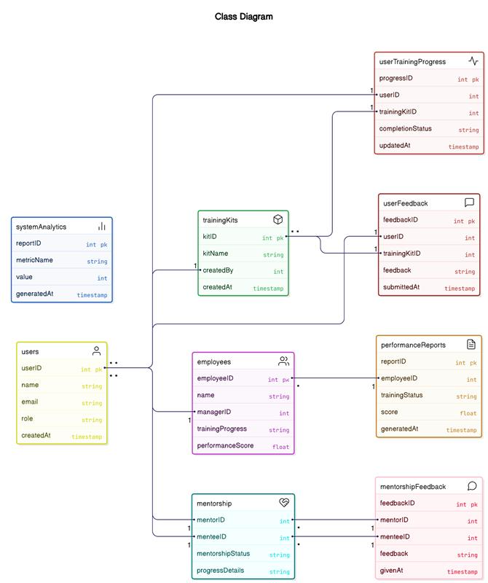

Fig 4.1 Class Diagram of KRISP-Insight

Fig 4.1 follows a structured design with interconnected entities. The MasterUser and Role classes handle user authentication, registration, and role-based access. The Orders and Cart modules manage food ordering, item selection, and the checkout process, while Payments and Payment Gateway ensure secure transactions through multiple payment methods. The Delivery and Order History components track order status, delivery progress, and user purchase history. Restaurants manage their offerings through MasterMenuItems, and users can provide feedback using the Remarks module. Additionally, the Notification system sends real-time updates, and the Bank entity verifies transactions, ensuring a seamless and secure food ordering experience.

### **Sequence diagram**

### 

Fi g 4.2 Sequence Diagram Of KRISP-Insight

Fig 4.2 represents the interactions between different actors such as User, Admin,

DeliveryAgent, RestaurantManager, and PaymentGateway with system components like MasterUser, Orders, Payments, PaymentGateway, Delivery, Remarks, UserFavorites, Cart, OrderHistory, Bank, Notifications, and MasterMenuItems. The process starts with User actions like Login(), Register(), and ForgotPassword(), followed by order-related operations such as

PlaceOrder(), UpdateOrderStatus(), CalculateTotalCost(), and CancelOrder(). The PaymentGateway handles ProcessPaymentRequest() and PaymentSuccessful(), while the DeliveryAgent performs UpdateDeliveryStatus() and ViewDeliveryHistory().The Admin manages operations like AddNewMenuItem(), RemoveItem(), and UpdateItemDetails(), while the Bank verifies transactions through CheckTransactionStatus().

### **Data Flow Diagram**

### **4.3.1 Admin Module**

### 

Fig 4.3.1 Data Flow Diagram Of Admin Module

**Data Flow Diagram (DFD) for Admin**

**Entities:**

* **Admin** (Main user)
* **System Users** (Employees, managers, module buddies)
* **Training System** (Manages training kits)

**Processes:**

1. **Manage Users, Roles & Permissions**
2. **Create & Update Training Kits**
3. **Monitor Analytics & Generate Reports**

**Data Stores:**

* **User Database** (Stores user details and roles)
* **Training Database** (Holds training kits)
* **Analytics & Reports Storage** (Stores generated reports)

**DFD Representation (Text Format):**

(Admin) → [Manage Users, Roles & Permissions] → (User Database)    
(Admin) → [Create & Update Training Kits] → (Training Database)    
(Admin) → [Monitor Analytics & Generate Reports] → (Analytics & Reports Storage)

4.3.2 Manager Module

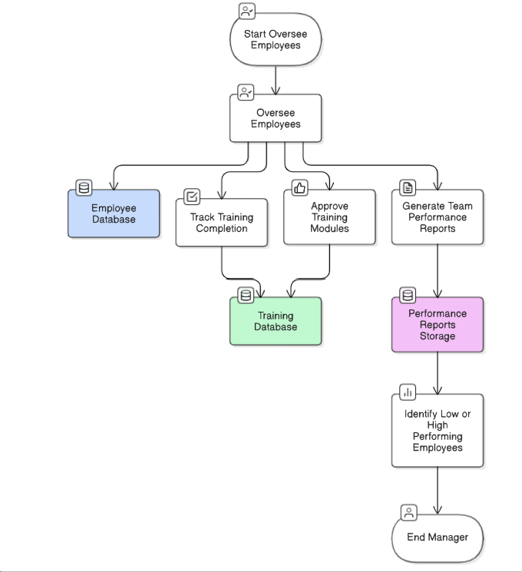

Fig 4.3.2 Data Flow Diagram Of Manager Module

**Data Flow Diagram (DFD) for Manager**  
**External Entities:**

Manager (User who oversees employees)  
Employees (Individuals being tracked)  
Training System (Source of training data)

**Processes:**

(P1) Oversee Employees  
(P2) Track Training Completion  
(P3) Approve Training Modules  
(P4) Generate Team Performance Reports  
(P5) Identify Low/High-Performing Employees

**Data Stores:**

(D1) Employee Database  
(D2) Training Database  
(D3) Performance Reports Storage

**Data Representation text format:**

(Manager) → [P1: Oversee Employees] → (D1: Employee Database)  
(Manager) → [P2: Track Training Completion] → (D2: Training Database)  
(Manager) → [P3: Approve Training Modules] → (D2: Training Database)  
(Manager) → [P4: Generate Team Performance Reports] → (D3: Performance Reports Storage)  
(D3: Performance Reports Storage) → [P5: Identify Low/High-Performing Employees] → (Manager)

4.3.3 **Module Buddy**

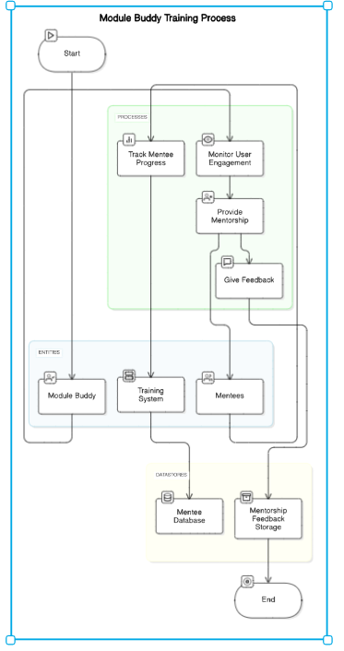

Fig 4.3.3 Data Flow Diagram Of Module Buddy

**Data Flow Diagram (DFD) for Module Buddy**

**Entities:**

* **Module Buddy** (Mentor user)
* **Mentees (Users receiving training)**
* **Training System** (Tracks progress)

**Processes:**

1. **Monitor User Engagement**
2. **Provide Mentorship**
3. **Track Mentee Progress**
4. **Give Feedback**

**Data Stores:**

* **Mentee Database** (Stores mentee details & progress)
* **Mentorship Feedback Storage** (Stores mentorship feedback)

**Data Representation Text Format:**

(Module Buddy) → [Monitor User Engagement] → (Mentee Database)    
(Module Buddy) → [Provide Mentorship] → (Mentee Database)    
(Module Buddy) → [Track Mentee Progress] → (Mentee Database)    
(Module Buddy) → [Give Feedback] → (Mentorship Feedback Storage)

4.3.4 User Module

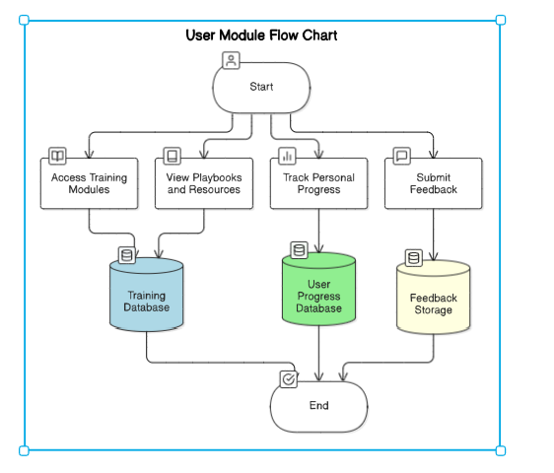

Fig 4.3.4 Data Flow Diagram Of User Module

**Data Flow Diagram (DFD) for User Module**

**Entities:**

* User (Trainee)
* Training System
* Module Buddy (Mentor)

**Processes:**

1. Access Training Modules
2. View Playbooks & Resources
3. Track Personal Progress
4. Submit Feedback

**Data Stores:**

* **Training Database** (Stores training materials)
* **User Progress Database** (Tracks progress)
* **Feedback Storage** (Stores user feedback)

**DFD Representation (Text Format):**

(User) → [Access Training Modules] → (Training Database)    
(User) → [View Playbooks & Resources] → (Training Database)    
(User) → [Track Personal Progress] → (User Progress Database)    
(User) → [Submit Feedback] → (Feedback Storage)

# CHAPTER 5 METHODOLOGY AND IMPLEMENTATION

### **User Roles and Functionalities**

### 5.1.1 Admin Module:

### Purpose:

### The Admin module manages users, training content, and system configurations. It provides access control and ensures smooth system operation.

### Responsibilities:

### • Manage users, roles, and permissions.

### • Create and update training kits.

### • Monitor system-wide analytics and generate reports.

### • Oversee security settings and data integrity.

### • Assign training modules to different roles.

### Dependencies:

### • User Module (to assign roles and permissions).

### • Training Database (to manage training kits).

### • Analytics & Reporting Module (to generate insights).

### • Security & Access Control Module (to enforce permissions).

### 3.1.2 Manager Module

### Purpose:

### The Manager module allows managers to oversee employees’ training progress and analyze team performance.

### Responsibilities:

### • Oversee employees' training progress.

### • Approve or reject training modules.

### • Track training completion and compliance.

### • Generate team performance reports.

### • Identify struggling or high-performing employees.

### Dependencies:

### • User Module (to track employees’ training status).

### • Training Database (to verify module completion).

### • Analytics & Reporting Module (to generate insights on performance).

### • Notification & Communication Module (to send reminders and alerts).

### 3.1.3. Module Buddy (Mentor) Module

### Purpose:

### The Module Buddy module allows mentors to support trainees by monitoring engagement and providing personalized guidance.

### Responsibilities:

### • Track mentee engagement with training modules.

### • Provide mentorship and guidance.

### • Give feedback on user performance.

### • Assess effectiveness of training programs.

### Dependencies:

### • User Module (to access mentee data).

### • Training Database (to monitor module progress).

### • Feedback Storage (to store mentorship feedback).

### • Notification & Communication Module (to communicate with mentees).

### 3.1.4. User Module (Trainee/Employee)

### Purpose:

### The User module provides employees access to training materials, assessments, and progress tracking.

### Responsibilities:

### • Access and complete assigned training modules.

### • View playbooks and learning resources.

### • Track personal progress and assessment scores.

### • Submit feedback on training sessions.

### • Engage with mentors for additional support.

### Dependencies:

### • Training Database (to retrieve assigned training modules).

### • User Progress Database (to track learning progress).

### • Feedback Storage (to store feedback on training sessions).

### • Notification & Communication Module (to receive training reminders).

* 1. **Admin Dashboard**

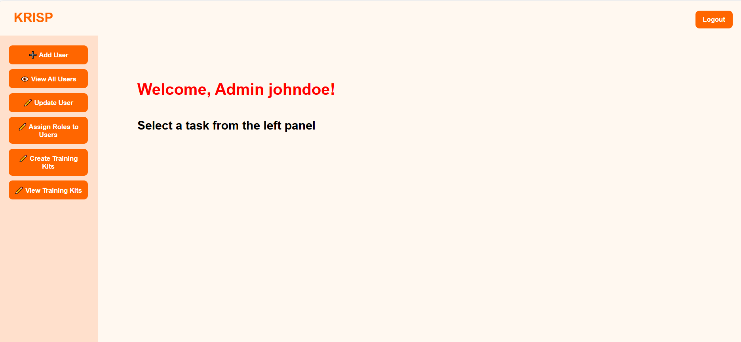

**Fig 5.2 Admin Dashboard**

**5.2.1 User Management**

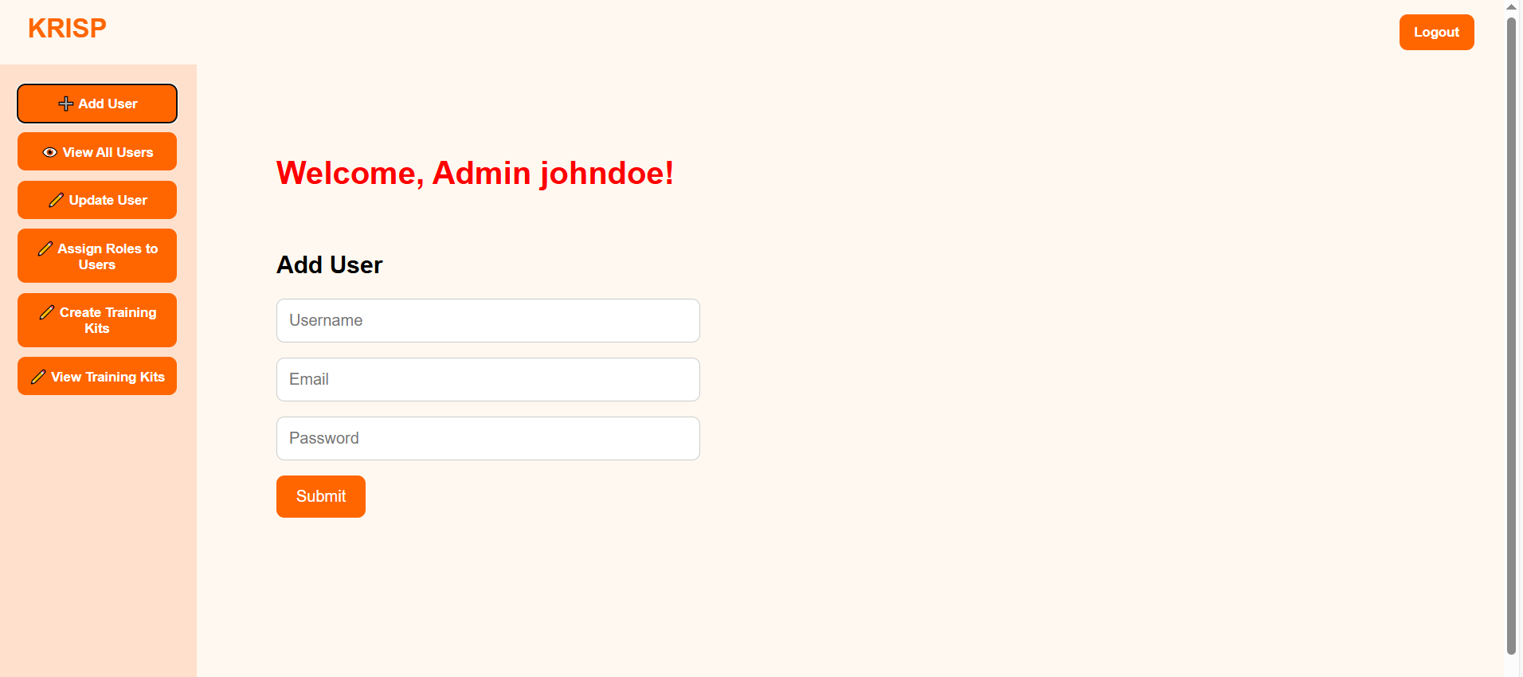

**Fig 5.2.1 Add User**

**5.2.2 Assign Roles to Users**

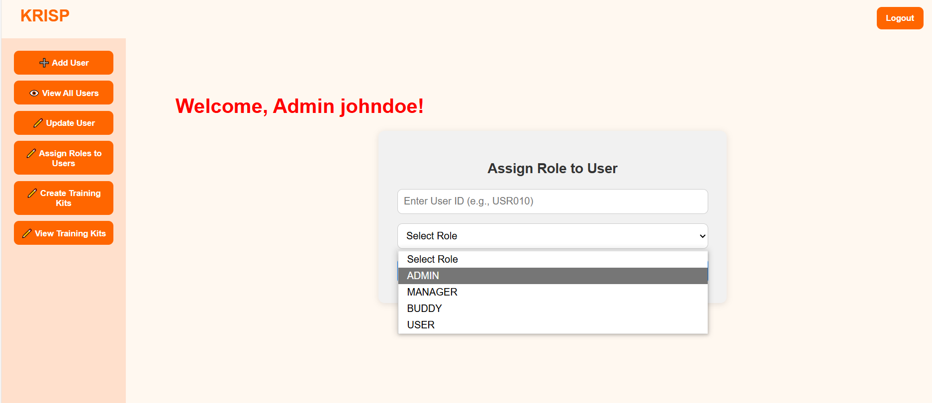

**Fig 5.2.3 Assign roles**

**5.2.3 Create Training Kits**

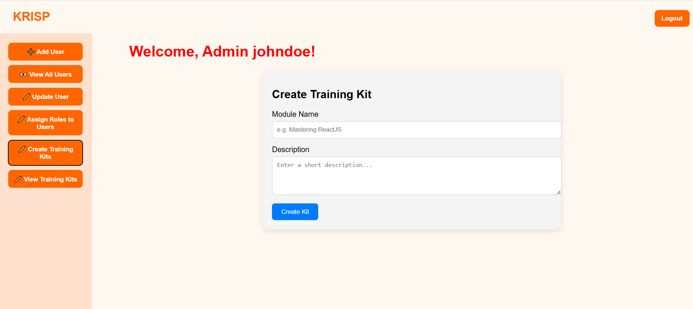

**Fig 5.2.3 Create Training Kits**

**5.2.4 View Training Kits**

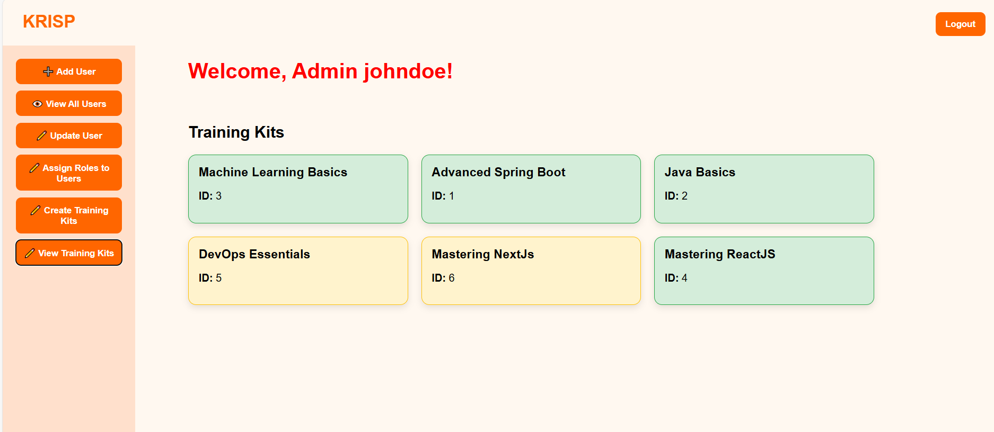

**Fig 5.2.4 View Training Kits**

**5.3 Manager Dashboard**

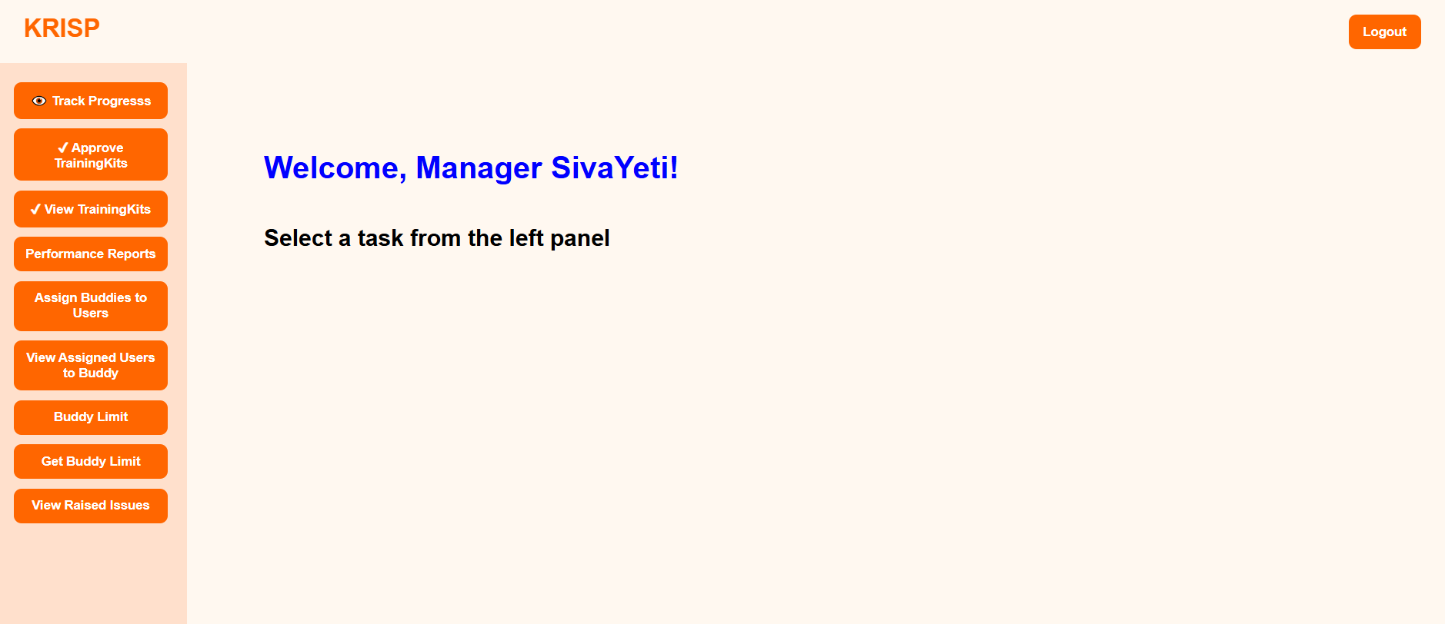

**Fig 5.3 Manager Dashboard**

**5.3.1 Track Progress**

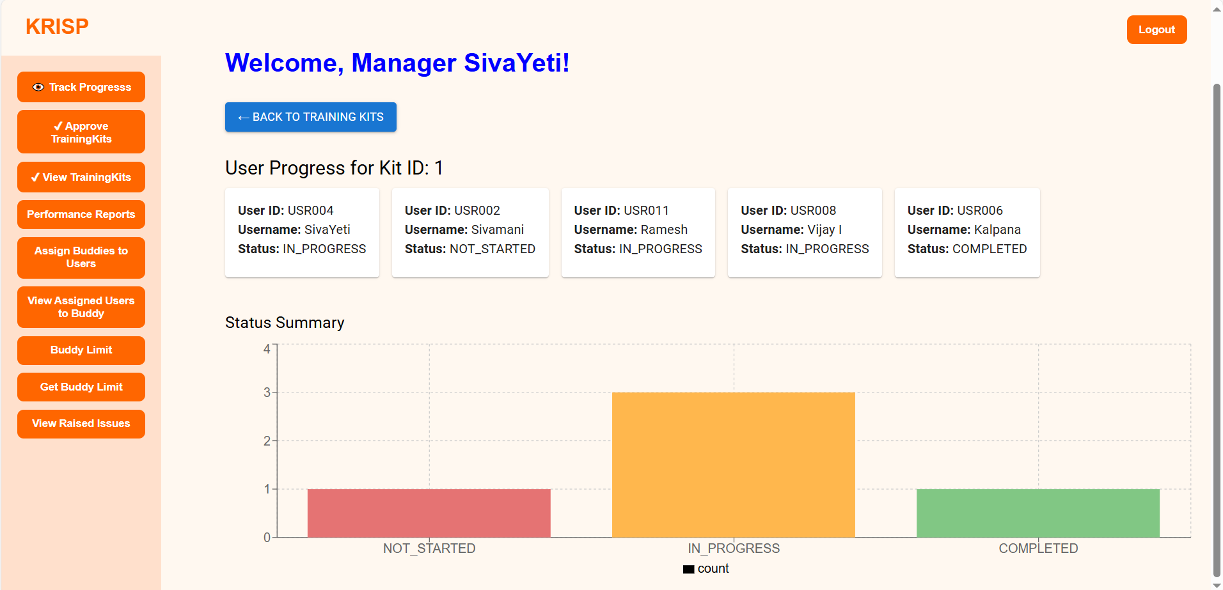

**Fig 5.3.1 Track Progress**

**5.3.2 Approve Training Kits**

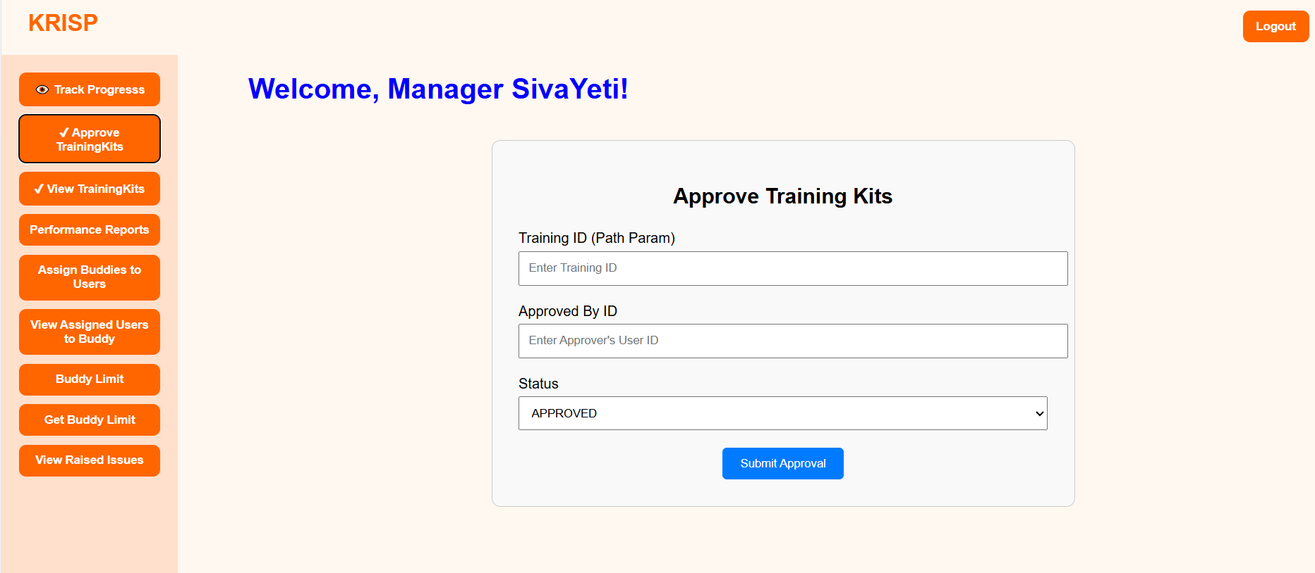

**Fig 5.3.2 Approve Training Kits**

**5.3.3 Performance Reports**

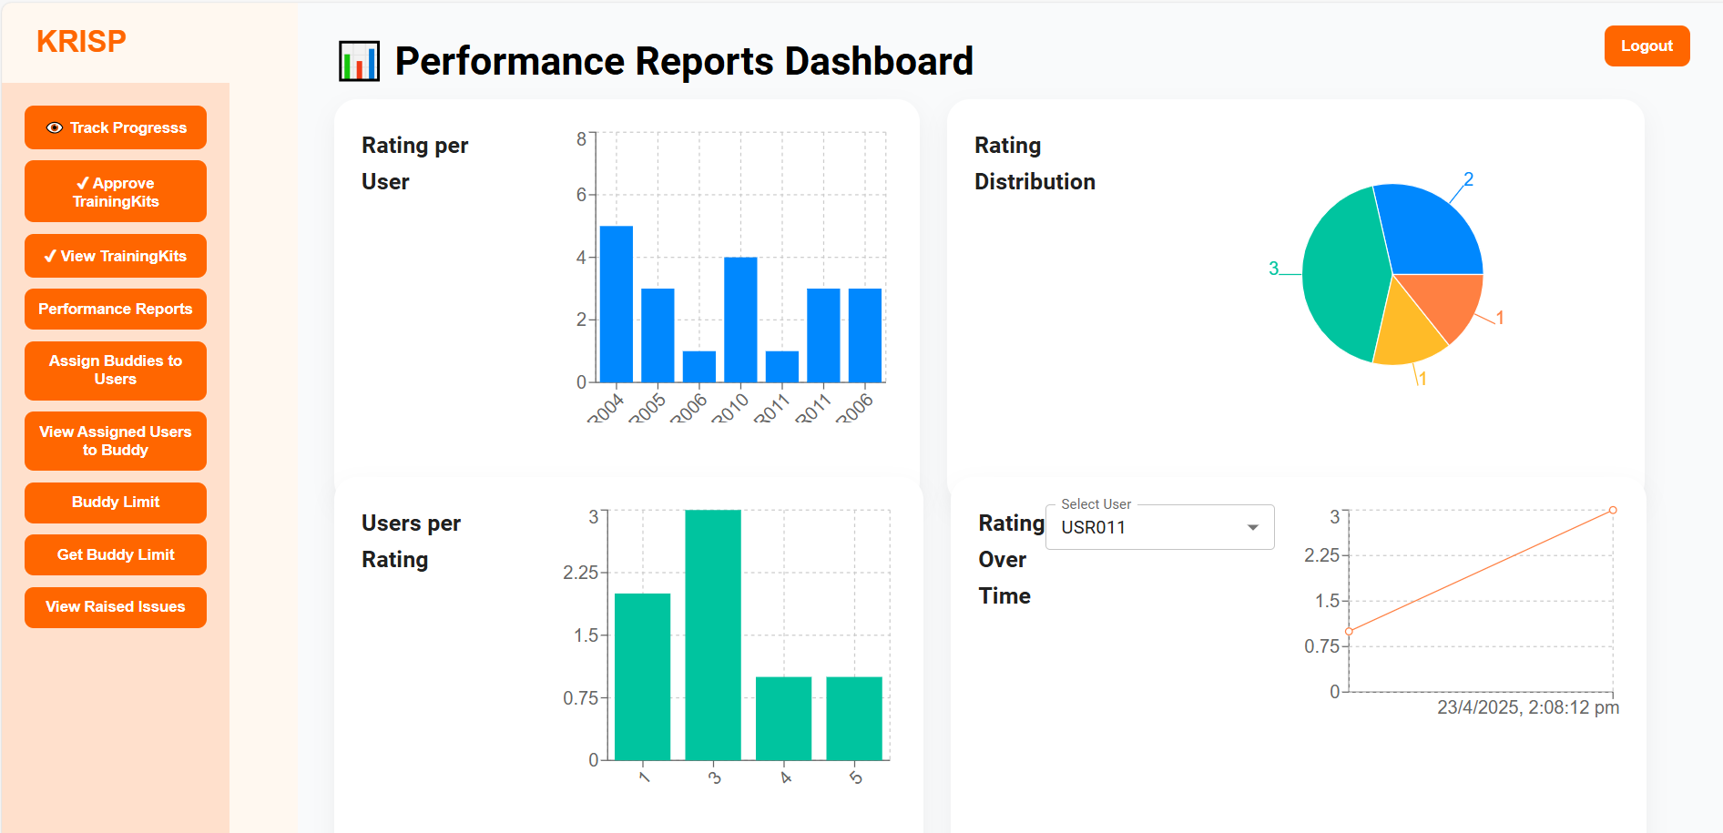

**Fig 5.3.3 Performance Reports**

**5.4 Buddy Dashboard**

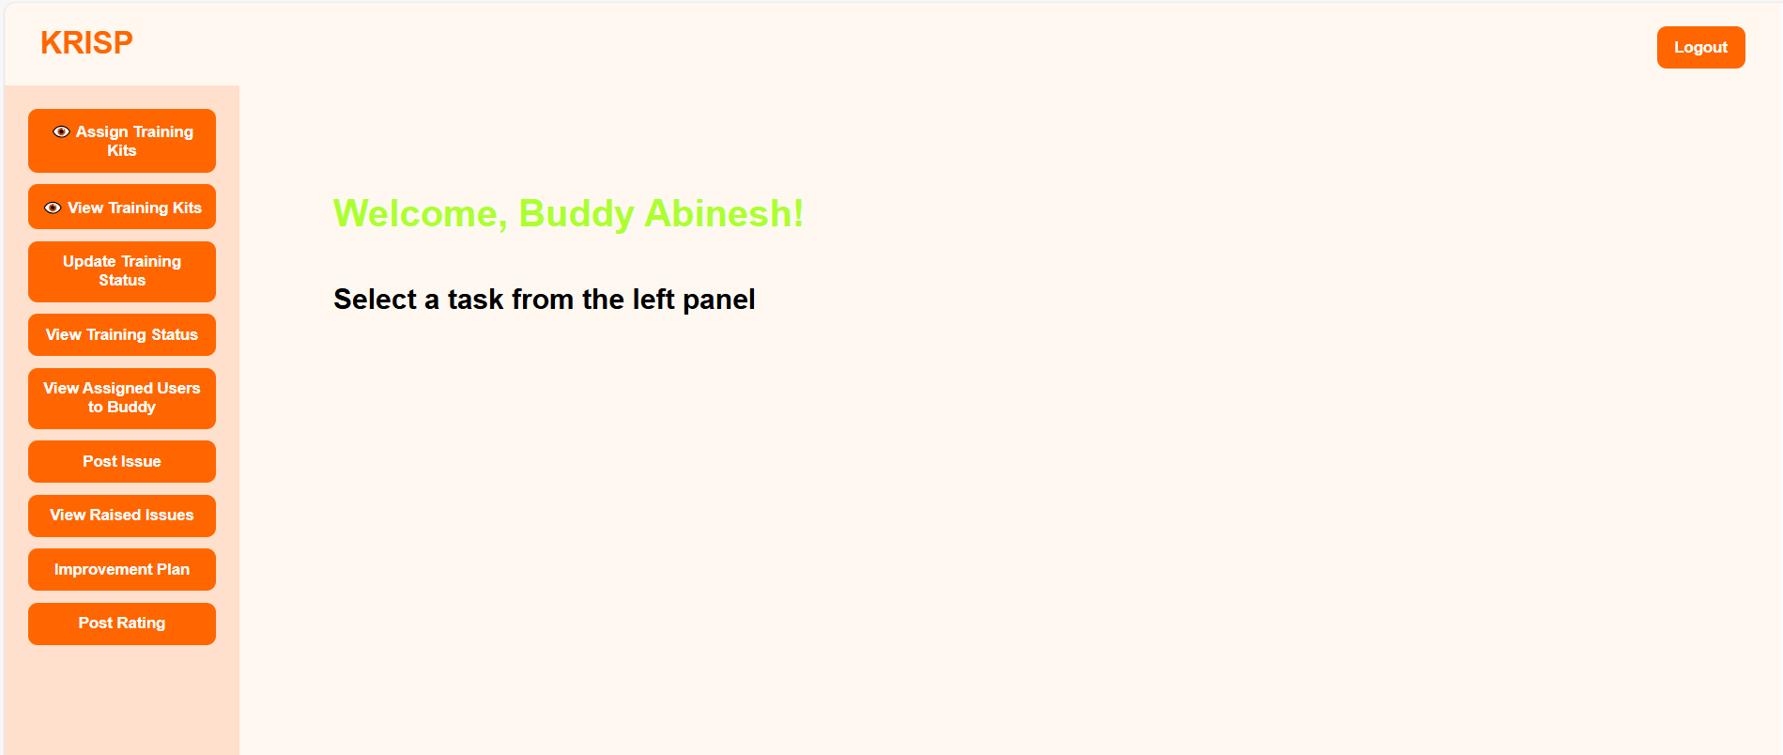

**Fig 5.4 Buddy Dashboard**

**5.4.1 Assign Training Kits**

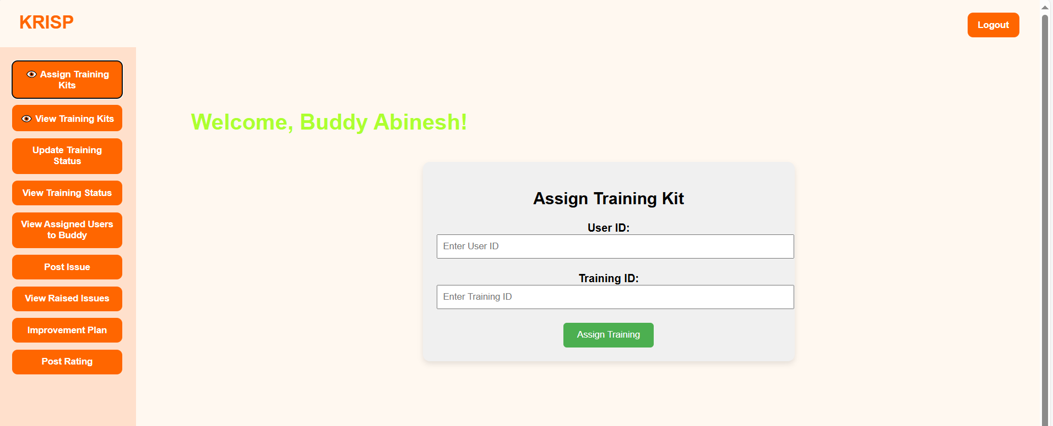

**Fig 5.4 .1 Assign Training Kits**

**5.4.2 View Training Status**

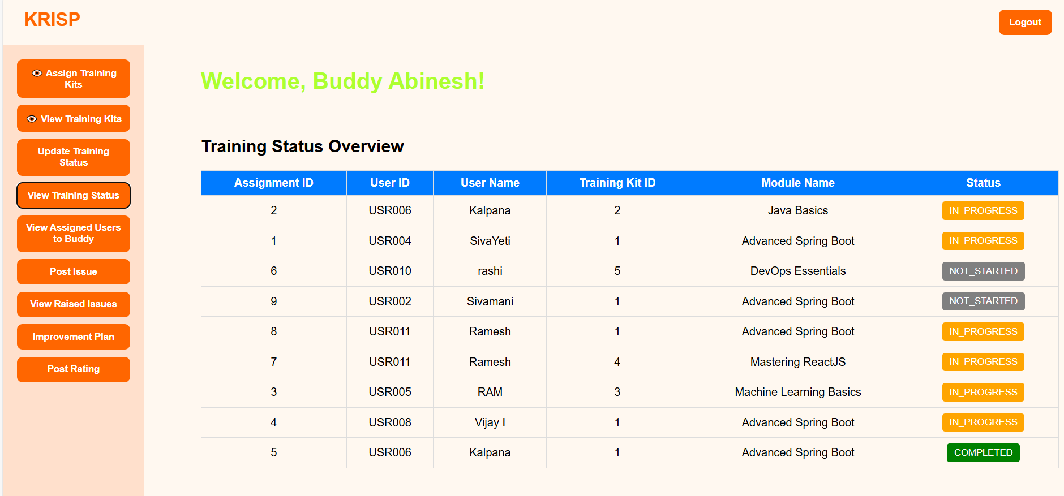

**Fig 5.4.2 Training Status**

**5.4.3 Improvement Plan**

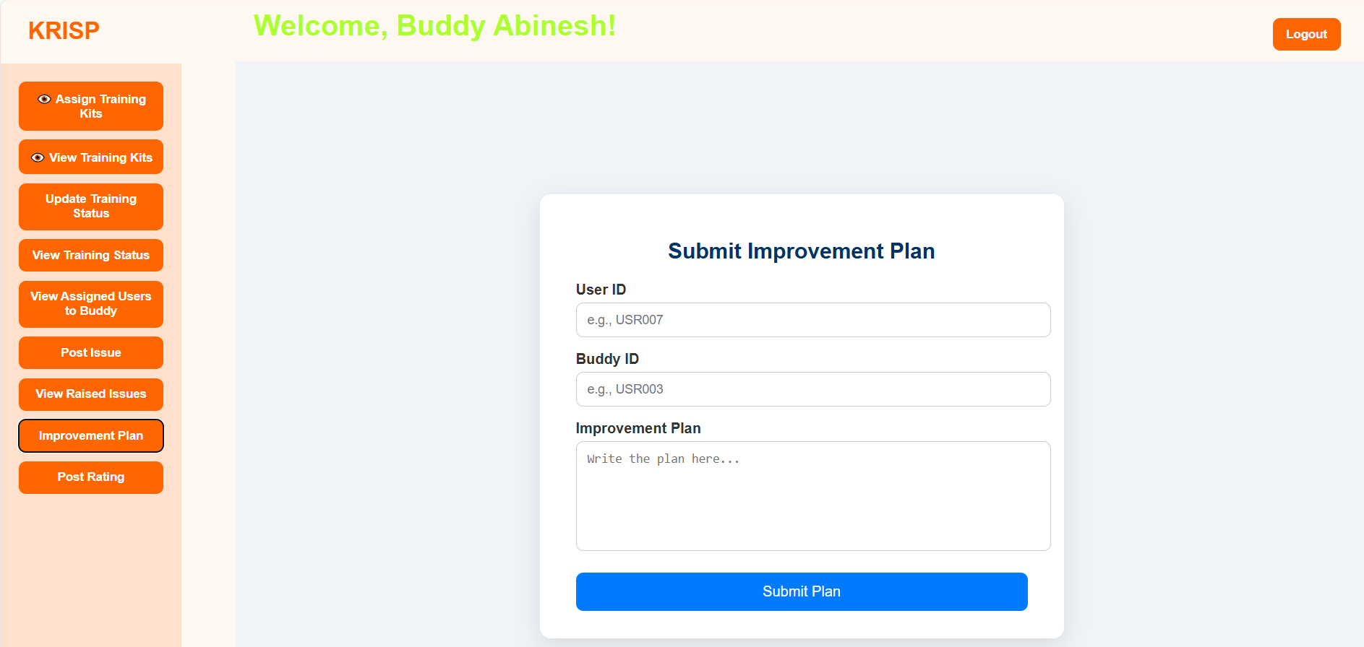

**Fig 5.4.3 Improvement Plan**

**5.4.4 Post Rating**

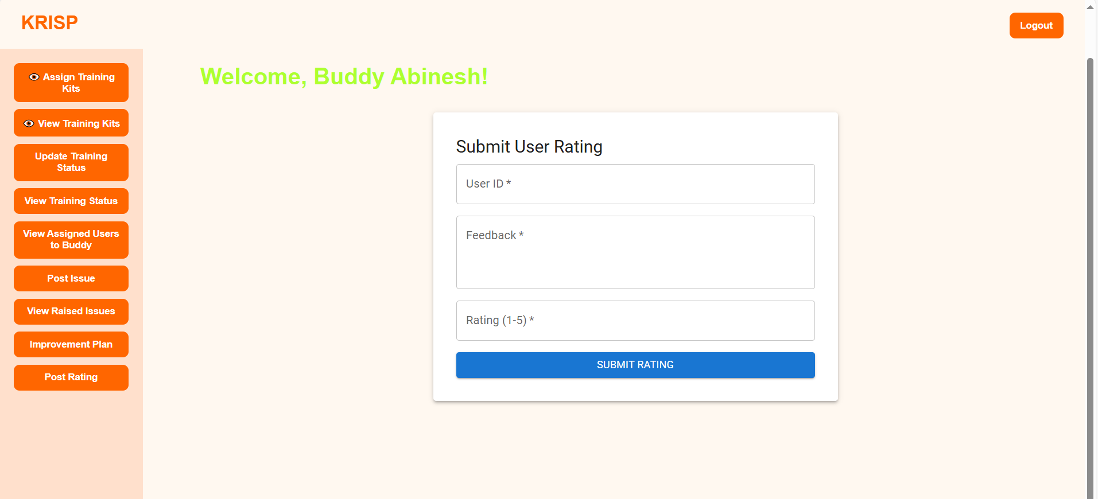

**Fig 5.4.4 Post Rating**

**5.5 User Dashboard**

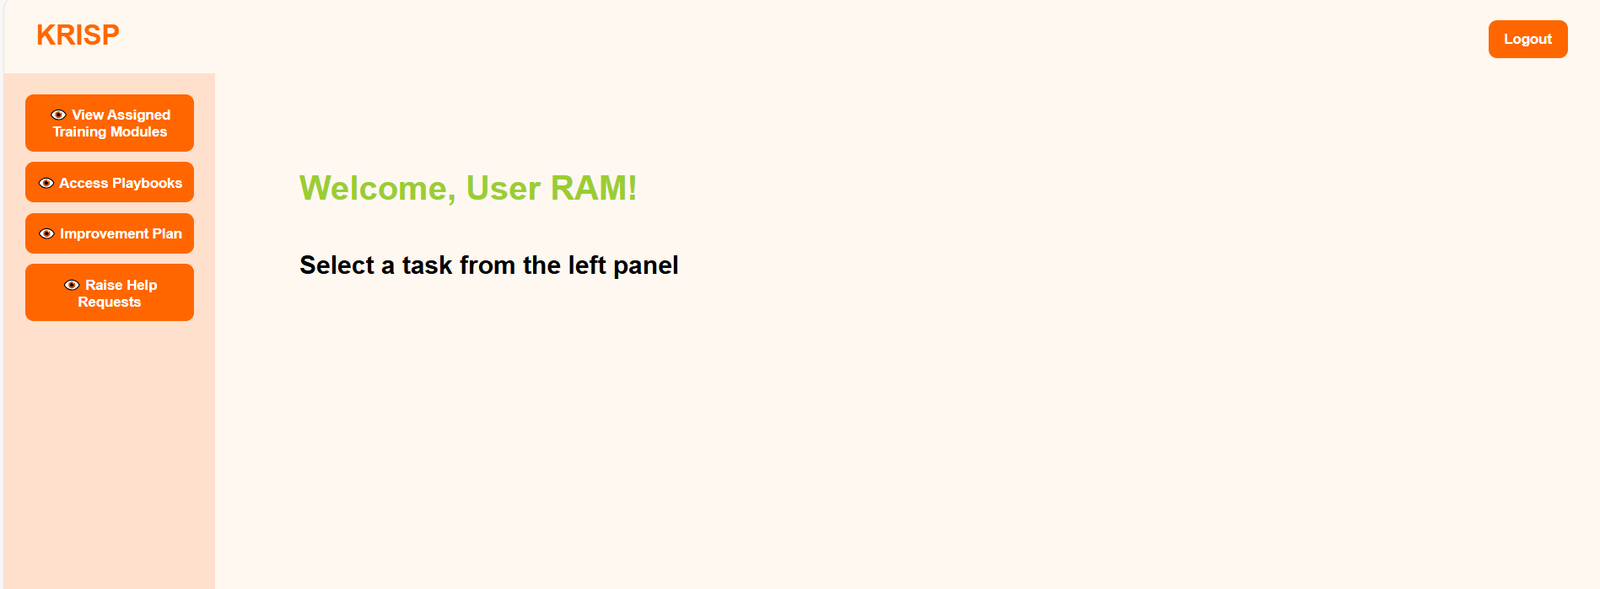

**Fig 5.5 User Dashboard**

**5.5.1 View Assigned Training Kits**

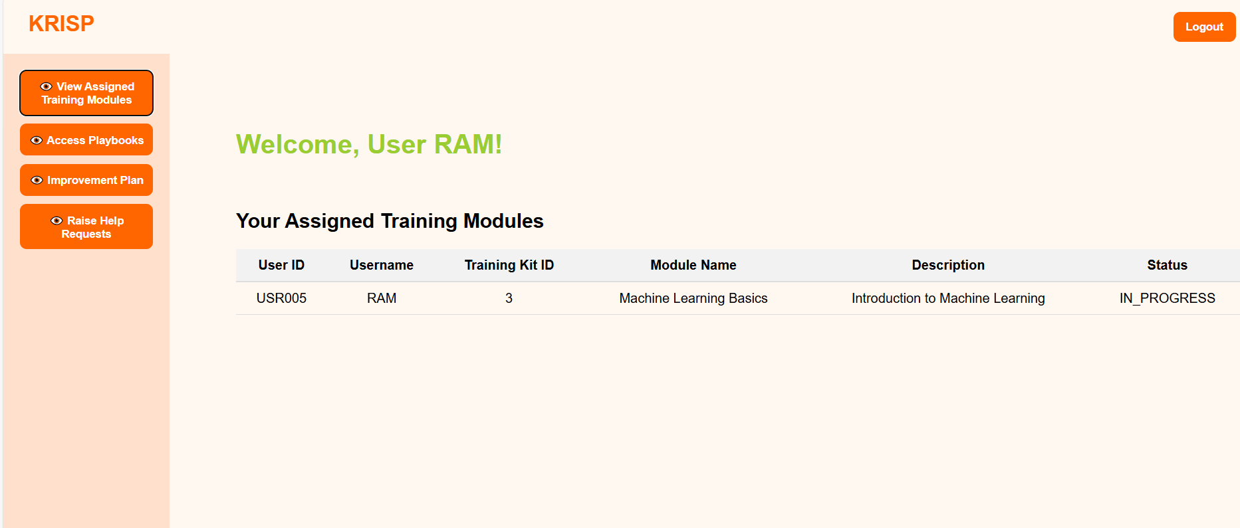

**Fig 5.5.1 View Assigned Training Kits**

**5.5.2 View Improvement Plan**

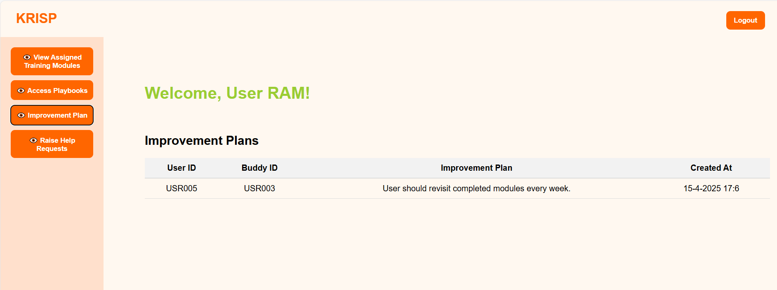

**Fig 5.5.2 View Improvement Plan**

# CHAPTER 6

CONCLUSION AND FUTURE ENHANCEMENTS

### Conclusion

Insight360 emerges as a comprehensive, scalable, and secure platform that addresses the evolving needs of enterprise learning and development. By incorporating robust **Role-Based Access Control (RBAC)**, secure authentication (via **Okta or Azure AD**), and a centralized PostgreSQL-backed architecture, the platform ensures that users interact with data and tools relevant to their roles—whether Admin, Manager, Module Buddy, or Employee.

The modular structure enhances system flexibility, enabling efficient training module management, real-time progress tracking, and actionable analytics. Seamless UI/UX powered by **Material UI** ensures accessibility across devices, while the centralized feedback loop strengthens mentorship and performance alignment. Compared to existing skill-building platforms, Insight360 stands out with its dynamic dashboard rendering, real-time data synchronization, and enterprise-level security integration.

Thus, the platform not only streamlines corporate training workflows but also empowers all stakeholders to make informed decisions, promoting a culture of learning, accountability, and continuous improvement.

### **Future Scope**

* **AI-Driven Recommendations**: Integrate machine learning models to provide intelligent suggestions for training modules, mentorship pairings, and career development paths based on user behavior and performance.
* **Gamification Features**: Add leaderboards, badges, and achievement tracking to enhance user engagement, motivation, and completion rates across modules.
* **Mobile App Integration**: Extend the platform with a cross-platform mobile app for learning on the go, ensuring wider accessibility and real-time notifications.
* **Third-Party LMS Integration**: Enable interoperability with popular LMS platforms like Moodle, Coursera for Business, or LinkedIn Learning to expand content offerings.
* **Blockchain Credentialing**: Incorporate blockchain to offer tamper-proof, verifiable digital certificates and skill badges for completed training and mentorship programs.
* **Natural Language Processing (NLP) in Feedback**: Use NLP to analyze qualitative feedback and derive sentiment trends or potential areas of concern within teams or modules.
* **Custom Report Builder**: Allow managers and admins to create custom analytics dashboards and export reports based on team, department, or training parameters.
* **Localization and Multi-Language Support**: Support multi-language dashboards and localized content to cater to global enterprises with a diverse workforce.

# REFERENCES

[1] K. Jadhav, P. Mehta, and A. Roy, “SkillSync: AI-Driven Learning Pathways for Enterprise Upskilling,” Jan. 12, 2024. Accessed: Apr. 02, 2025. [Online]. Available: http://example.com/skillsync

[2] P. Sharma, R. Verma, and L. Iyer, “Upskill360: Leveraging Analytics to Drive Corporate Learning Outcomes,” Feb. 08, 2024. Accessed: Apr. 02, 2025. [Online]. Available: http://example.com/upskill360

[3] A. Patel, M. Sinha, and V. Kapoor, “SkillWise: Intelligent Mentor-Mentee Matching and Learning Progress Tracking,” Mar. 15, 2024. Accessed: Apr. 02, 2025. [Online]. Available: http://example.com/skillwise

[4] D. Rao, T. Deshmukh, and S. Kumar, “LearnEdge: A Role-Centric Training System for Enterprise Learning Management,” Apr. 10, 2024. Accessed: Apr. 02, 2025. [Online]. Available: http://example.com/learnedge

[5] R. Krishnan, A. Bhatt, and K. Sen, “SkillForge: Gamified Learning Platform for Workforce Development,” May 06, 2024. Accessed: Apr. 02, 2025. [Online]. Available: http://example.com/skillforge

[6] N. Bansal, Y. Rao, and M. Chatterjee, “EduChain: Blockchain-Based Learning Credential Verification System,” Jun. 20, 2024. Accessed: Apr. 02, 2025. [Online]. Available: http://example.com/educhain

# BIBILIOGRAPHY

1. Spring Boot Reference Documentation. Available: <https://spring.io/projects/spring-boot>
2. Spring Data JPA Documentation. Available: <https://spring.io/projects/spring-data-jpa>
3. Hibernate ORM Documentation. Available: <https://hibernate.org/orm/documentation/>
4. Maven Documentation. Available: <https://maven.apache.org/guides/index.html>
5. Spring Security Documentation. Available: <https://spring.io/projects/spring-security>
6. REST API Design Guidelines. Available: <https://restfulapi.net/>
7. PostgreSQL 15 Documentation. Available: <https://www.postgresql.org/docs/15/>
8. JDBC (Java Database Connectivity) Documentation. Available: <https://docs.oracle.com/javase/8/docs/technotes/guides/jdbc/>
9. React Official Documentation. Available: https://reactjs.org/docs/getting-started.html
10. Material-UI (MUI) Documentation. Available: https://mui.com/material-ui/getting-started/overview/
11. Framer Motion Documentation. Available: https://www.framer.com/motion/
12. Styled Components Documentation. Available: https://styled-components.com/docs
13. GSAP (GreenSock Animation Platform) Documentation. Available: https://greensock.com/docs/
14. React Awesome Reveal Documentation. Available: https://react-awesome-reveal.morello.dev/
15. Axios (HTTP Client for React). Available: https://axios-http.com/docs/intro
16. Bootstrap Documentation. Available: <https://getbootstrap.com/>